2023 Alabama Peer Conference Submission

Mark Litvine CRSS/CPS

Bio

Mark Litvine is a person in long term recovery from a substance use disorder and mental health diagnosis. Mark uses his lived experience to provide hope, assistance, guidance, understanding and encouragement to the individuals that he serves. Mark started out by volunteering as a peer at the Birmingham Fellowship House and was in the first class of state Certified Recovery Peer Support Specialists in Alabama in March 2016. Mark is also a Certified Peer Specialist on the Mental Health side as well. Mark is one of the founders of R.O.S.S. the first Recovery Community Organization in Alabama and Mark is the Director of Marketing for the Recovery Organization Of Support Specialist. Mr. Litvine also trains the state Certified Recovery Support Specialists. Mark received the Peer Warrior Award in 2017 for his hard work and dedication to the peers in Alabama. Mark serves on the Alabama Opioid Task Force and Ethical Peer Accountability Committee for the state Certified Peers in Alabama. Mr. Litvine was taught early on in his recovery that he lives a life of purpose today which is to help others and make a difference in his community.

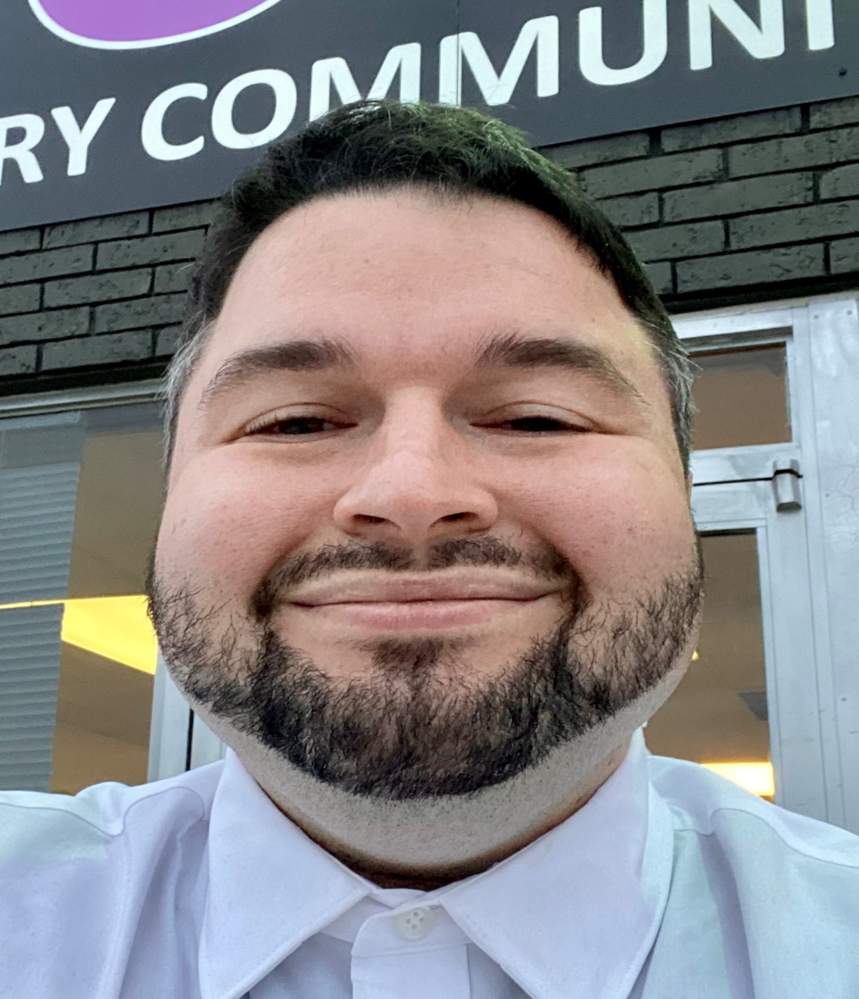

Course Description –

Title Recovery Advocacy 101

Learn the ins and outs of starting a grassroots Recovery Advocacy Movement in Alabama what you need to know to get started. Learn about Advocacy Outcomes & Advocacy Issues and what stakeholders to reach out to in Alabama. Learn about Smart Advocacy Objectives and the different approaches to Advocacy. Learn about why Recovery Advocacy matters in Alabama and how because of the Covid 19 Pandemic it is easier to get started with any type of Advocacy by utilizing technology and Virtual Platforms.

Learning Objectives –

- The individual will learn why Recovery Advocacy Matters in Alabama and what they need to do to get started.
- The individual will learn about different approaches to Advocacy, Advocacy Outcomes, Advocacy Issues and what Smart Advocacy Objectives look like.
- The individual will learn how it is easier to get started with Advocacy because of the Covid 19 Pandemic by utilizing technology and Virtual Platforms.

